
SUBMITTED BY:
Name: | Siddarth A
Roll no: | AV.SC.U4CSE25005
Branch: | CSE
Section: | CSE-A

SUBMITTED TO:
Name: | DR. Raj Kumar Batchu
Department: | School Of Computing
Designation: | Asst. Proffesor

Subject: Data Structures and Algorithms(DSA)
Credits:

Week-1

1)Aim: To implement recursion in Python by creating a function that prints numbers in descending order from a given number.
Program:
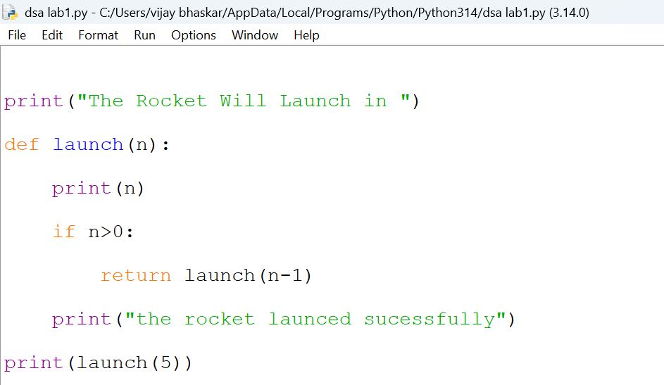
Output:
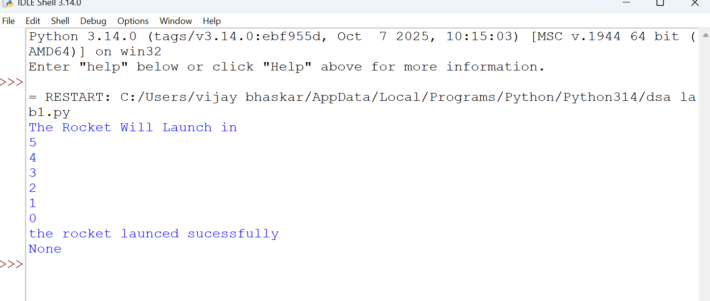
Explanation:
· The function launch(n) prints the current value of n.
· If n is greater than 1, it decreases n by 1 and calls itself recursively.
· The recursion continues until n becomes 0, which is the base case, and the function stops.
Error Table:
S.No | Error Obtained | Rectification
01. | Didn’t write the print statement after definition. | After execution I found the mistake and added it.

2)Aim: To implement a recursive binary search in Python to find the position (index) of a given element in a list. The program recursively checks each element of the list until the target element is found or the end of the list is reached.
Program:
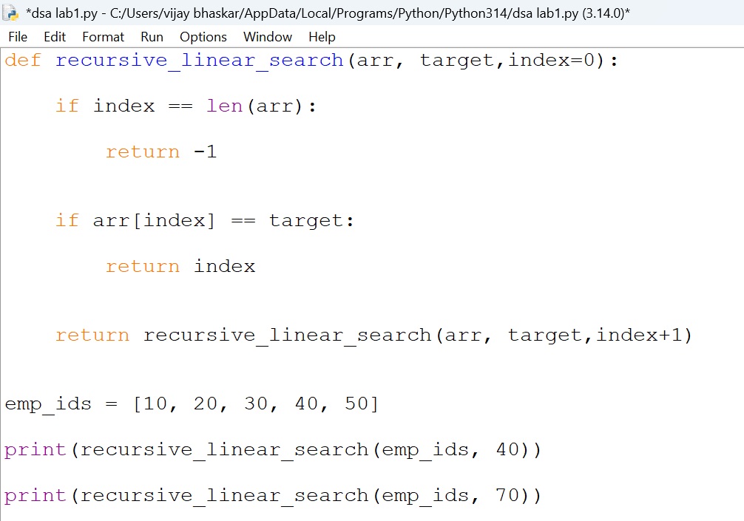
Output:
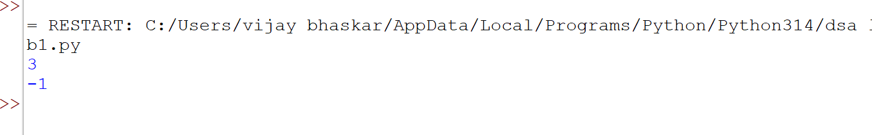

Explanation:
This program uses recursion to perform a linear search for an employee ID (or any target element) in a list.
- The function empid_Search(arr, target, n=0) is defined with three parameters:
  - arr: The list in which the search is performed.
  - target: The element to be searched.
  - n: The current index, initialized to 0.
- The statement if n == len(arr): return -1 is the base condition. It checks whether all elements in the list have been examined. If the end of the list is reached without finding the target, the function returns -1.
- The statement if arr[n] == target: return n compares the current element with the target. If they are equal, the function returns the current index where the target is found.
- If the current element does not match the target, the function calls itself recursively with the next index using return empid_search(arr, target, n + 1).
- The list arr = [10, 20, 30, 50, 607, 809, 506] is created, and the function is called to search for the element 50.
- The returned value is stored in the variable result.
- If result is not equal to -1, the program prints the index where the element is found. Otherwise, it prints "Element not found."
Error table:
S.No | Error Obtained | Rectification
01. | Recursion Error: maximum recursion depth exceeded | Increment the index in the recursive call: return empid_Search(arr, target, n + 1).

3)Aim: This Python program uses recursion to calculate the value of pⁿ (p raised to the power n)
Program:
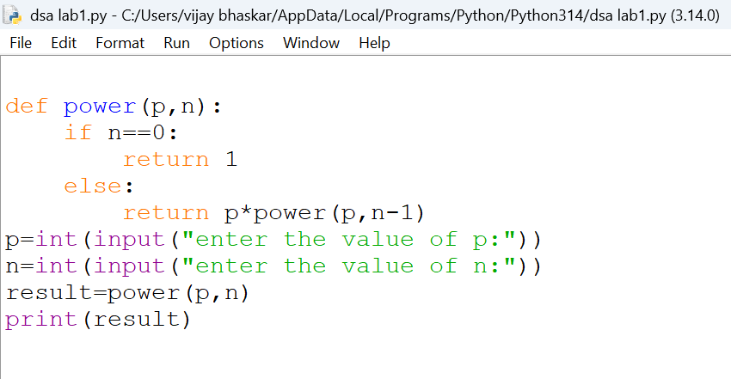
Output:
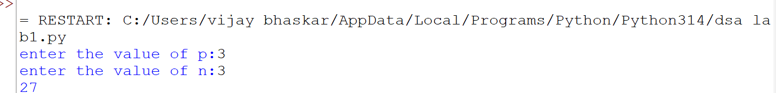
Explanation:
- The program is used to find the power of a number (pⁿ) using recursion.
- It takes two inputs from the user:
- p → Base number
- n → Exponent (power)
- The function power(p, n) is called to calculate the result.
- If the exponent n is 0, the function returns 1 because any number raised to the power 0 is
- If n is not 0, the function calls itself with n - 1 and multiplies the result by p.
- This recursive process continues until the exponent becomes 0.
- After reaching the base case, each recursive call returns its result, and the final value of pⁿ is obtained.
- The result is stored in the variable result.
- Finally, the program prints the calculated power of the given number.
Error Table:
S. No | Error Obtained | Rectification
01. | Not a int value of n we can also take float in place of int, I have taken float value to check. | By replacing int by float.

4)Aim: To write a Python program that generates and prints the Fibonacci series up to n terms using recursion.
Program:
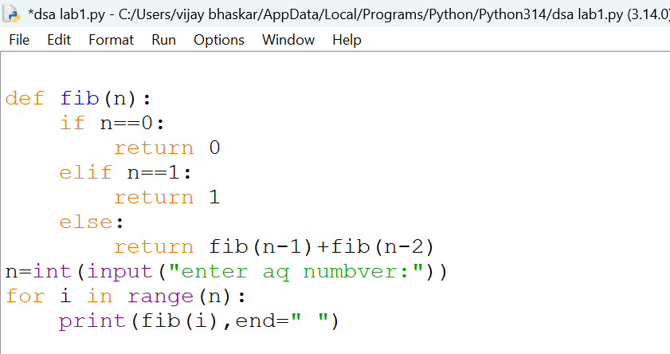
Output:
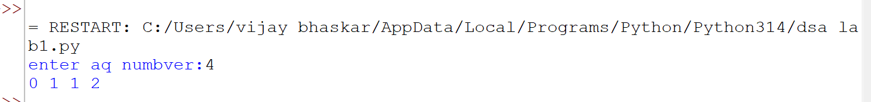
Explanation:
- The base condition returns 0 when n = 0 and 1 when n = 1.
- For values greater than 1, the function returns the sum of the previous two Fibonacci numbers: fib(n-1) + fib(n-2).
- The user enters the number of terms (n) to be displayed.
- A for loop calls the fib () function repeatedly for each term from 0 to n-1.
- Finally, the program prints the Fibonacci series in sequence.
Error Table:
S. No | Error Obtained | Rectification
01. | No Errors obtained | -----------------------------------------

5)Aim: To write a Python program to find the factorial of a given number using recursion.
Program:
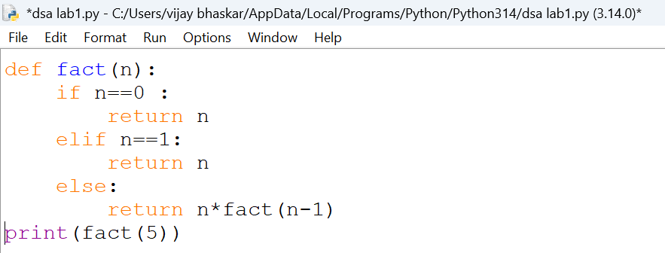
Output:
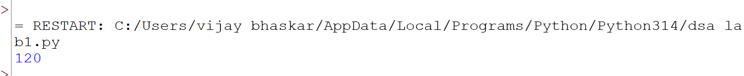
Explanation:
- The program defines a recursive function fact(n) to calculate the factorial of a number.
- The base condition checks if n <= 1. If true, it returns 1 (for factorial, 0! = 1 and 1! = 1).
- Otherwise, the function returns n * fact(n-1), multiplying the current number by the factorial of the previous number.
- The function is called with the value 6.
- Finally, the program prints the factorial of 6, which is 720.
Error Table:
S. No | Error Obtained | Rectification
01. | No Errors | ---------------------------------------------------

Week-2
1)Aim: To write a Python program to search for a given element in an array using the Linear Search technique and display its position.
Program:
def linear_search(arr,key):
for i in range(len(arr)):
if arr[i]==key:
return i
else:
i=i+1
return 0
arr=list(map(int,input().split()))
key=int(input("Enter the element to be searched:"))
print(linear_search(arr,key))
Output:
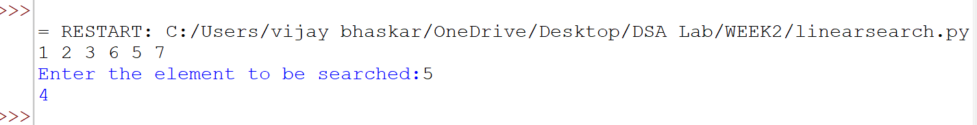

Explanation:
• The program defines a function linear_search() to search for an element in a list.
• It takes two inputs: the array (arr) and the element to be searched (key).
• The for loop checks each element of the array one by one.
• If arr[i] == key, the function returns the index of the element.
• If the element is not found, the function returns 0.
• The user enters the array elements and the element to be searched.
• Finally, the program calls linear_search() and prints the result.
Error Table:
S.No | Error Obtained | Rectification
01. | Error in input taking of array | Rectified by split.

2)Aim:To write a Python program to search for a given element in an array using the recursive Binary Search technique, by checking whether the array is sorted and sorting it if necessary.
Program:
FOR SORTED ARRAY:

def binary\_search(arr,key,low,high):
if low>high:
return -1
mid=(low+high)//2
if arr[mid]==key:
return mid
elif arr[mid]>key:
return binary_search(arr,key,low,mid-1)
else:
return binary_search(arr,key,mid+1,high)
return 0
arr=list(map(int,input().split()))
key=int(input("Enter the element to be searched:"))
print(binary\_search(arr,key,0,len(arr)))

FOR UNSORTED ARRAY:
def binary\_search(arr,key,low,high):
if low>high:
return -1
mid=(low+high)//2
if arr[mid]==key:
return mid
elif arr[mid]>key
return binary_search(arr,key,low,mid-1)
else:
return binary_search(arr,key,mid+1,high)
return 0
arr=list(map(int,input().split()))
key=int(input("Enter the element to be searched:"))
if arr==sorted(arr):
print("The array is sorted")
else:
print("The array is not sorted")
arr.sort()
print("The sorted array is:",arr)
print(binary_search(arr,key,0,len(arr)))
Output:
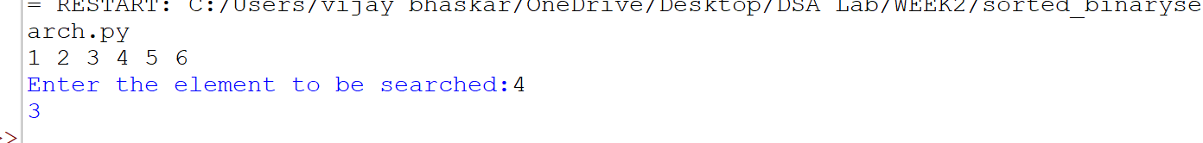
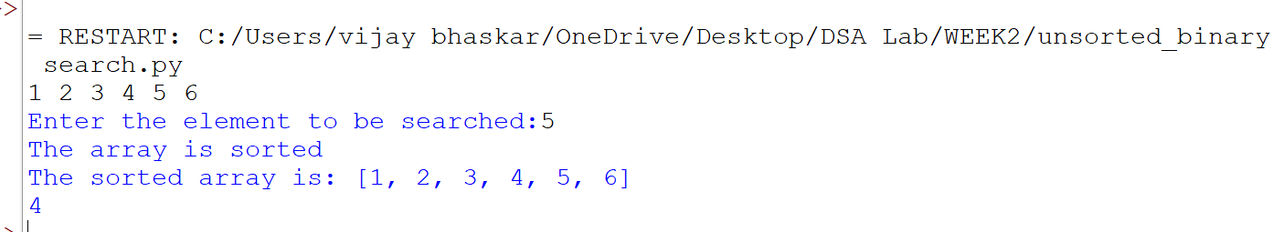
Explanation:
• The program uses Binary Search to find a given element in an array.
• The binary_search() function works recursively by dividing the search range into two halves.
• It calculates the middle position using (low + high) // 2.
• If the middle element is equal to the key, its index is returned.
• If the middle element is greater than the key, the function searches the left half.
• If the middle element is smaller than the key, it searches the right half.
• For an unsorted array, the program first checks whether the array is sorted using arr == sorted(arr).
• If it is not sorted, arr.sort() is used to arrange the elements in ascending order.
• Finally, the Binary Search function is called to search for the required element.

Error Table:
S.No | Error Obtained | Rectification
01. | Error in if clause statement | Rectified by keeping ==

